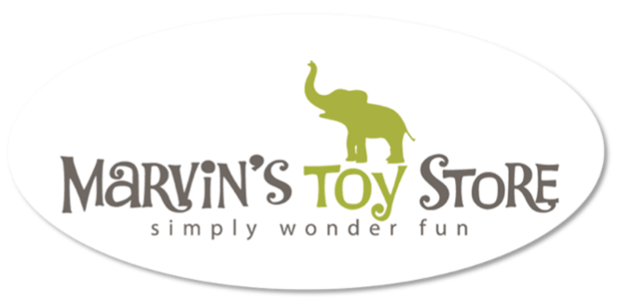

Job Description: Customer Service Representative at Marvin's Toy Store
Position: Toy Expert /Customer Service Representative
Location: Marvin's Toy Store, Downtown Crystal Lake, Downtown Barrington, McHenry Riverwalk
About Marvin's Toy Store: Marvin's Toy Store is a specialty toy store dedicated to providing a fun, earth-friendly, and unique shopping experience for children and families. We offer a wide selection of high-quality toys, games, and gifts that inspire creativity, imagination, and play.
Job Summary: We are seeking a friendly, enthusiastic, and customer-focused individual to join our team as a Toy Expert/Customer Service Representative. In this role, you will be responsible for providing exceptional service to our customers, assisting them in finding the perfect toys and gifts, and ensuring a positive shopping experience in our store.
Responsibilities:
- Greet customers warmly and assist them in finding products that meet their needs and preferences.
- Provide product information, recommendations, and demonstrations to customers.
- Process transactions accurately and efficiently using our point-of-sale system.
- Handle customer inquiries, concerns, and complaints in a professional and courteous manner.
- Maintain a clean and organized store environment, including restocking shelves and tidying up displays.
- Assist with inventory management tasks, such as receiving shipments and conducting stock counts.
- Contribute to a positive team environment by collaborating with coworkers and supporting store initiatives.

Qualifications:
- Must be 18+
- High school diploma or equivalent.
- Prior customer service experience a plus.
- Passion for toys and a genuine interest in providing exceptional service to customers.
- Excellent communication and interpersonal skills.
- Self motivated – there are times you will be working by yourself
- Strong attention to detail and accuracy.
- Flexible schedule, including availability to work evenings, weekends, and some holidays. (we are closed all major holidays)
Benefits:
- Competitive hourly wage.
- Employee discounts on merchandise.
- Opportunities for professional development and advancement within the company.
- Fun and supportive work environment with a focus on creativity and play.
How to Apply: If you are passionate about toys and enjoy working in a dynamic retail environment, we would love to hear from you! Please complete the application and submit a brief cover letter highlighting your relevant experience and why you would be a great fit for the Toy Expert/Customer Service Representative position at Marvin's Toy Store.
Join Our Team: At Marvin's Toy Store, we believe in the power of play to inspire joy and creativity. Join our team and help us create memorable experiences for children and families in our community!
Marvin's Toy Store is an equal opportunity employer. We celebrate diversity and are committed to creating an inclusive environment for all employees.

