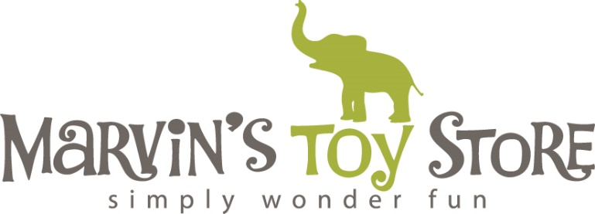

Marvin's Toy Store - Job Application
Position: Customer Service/Toy Expert
Dear Applicant,
Thank you for considering Marvin's Toy Store as your potential workplace. We are thrilled to see your interest in joining our team and becoming a part of our mission to provide a fun and memorable experience for our customers. Please fill out the following application to be considered for the Customer Service/Toy Expert position.
Personal Information:
- Full Name:
- Phone Number:
- Email Address:
- Address:

Work Experience:
Employer Company Name:
Employer Phone Number:
Job Title:
Job Responsibilities:
Start Date: End Date:
Reason for Leaving:

Employer Company Name:
Employer Phone Number:
Job Title:
Job Responsibilities:
Start Date: End Date:
Reason for Leaving:

Employer Company Name:
Employer Phone Number:
Job Title:
Job Responsibilities:
Start Date: End Date:
Reason for Leaving:

Education:
High School Name:
Graduation Year:

College:
Graduation Year:
List your educational background, including any relevant coursework or certifications.

Favorite Toy:
Tell us about your favorite toy growing up and why it was special to you.

Why Marvin's Toy Store?
What inspired you to apply for a position at Marvin's Toy Store? Please share why you are passionate about working in a specialty toy store environment.

Creative Skills:
Do you have any creative skills or hobbies that you believe would be beneficial in a toy store environment? (e.g., crafting, storytelling, etc.)

Gift Wrapping:
Describe your experience with gift wrapping, if any. How do you ensure that each gift is beautifully presented to our customers?

References:
Please provide the names and contact information for two professional references who can speak to your qualifications for this position.
- Name:
Relationship:
Phone Number:
Email:
- Name:
Relationship:
Phone Number:
Email:
Declaration:
I certify that all information provided in this application is true and accurate to the best of my knowledge.
Signature:
[Your Signature]
Date:
[Date]
Thank you for taking the time to apply to Marvin's Toy Store! We appreciate your interest in joining our team, and we look forward to reviewing your application.
Sincerely,
Kate and Lori McConville
Owners
Marvin's Toy Store

